SETTING UP THE APPLICATION ENVIRONMENT

Create an Account in Sendgrid

|  |  |
| --- | --- |
| **DATE** | 27 October 2022 |
| **TEAM ID** | PNT2022TMID52830 |
| **PROJECT NAME** | Inventory Management System for Retailers |

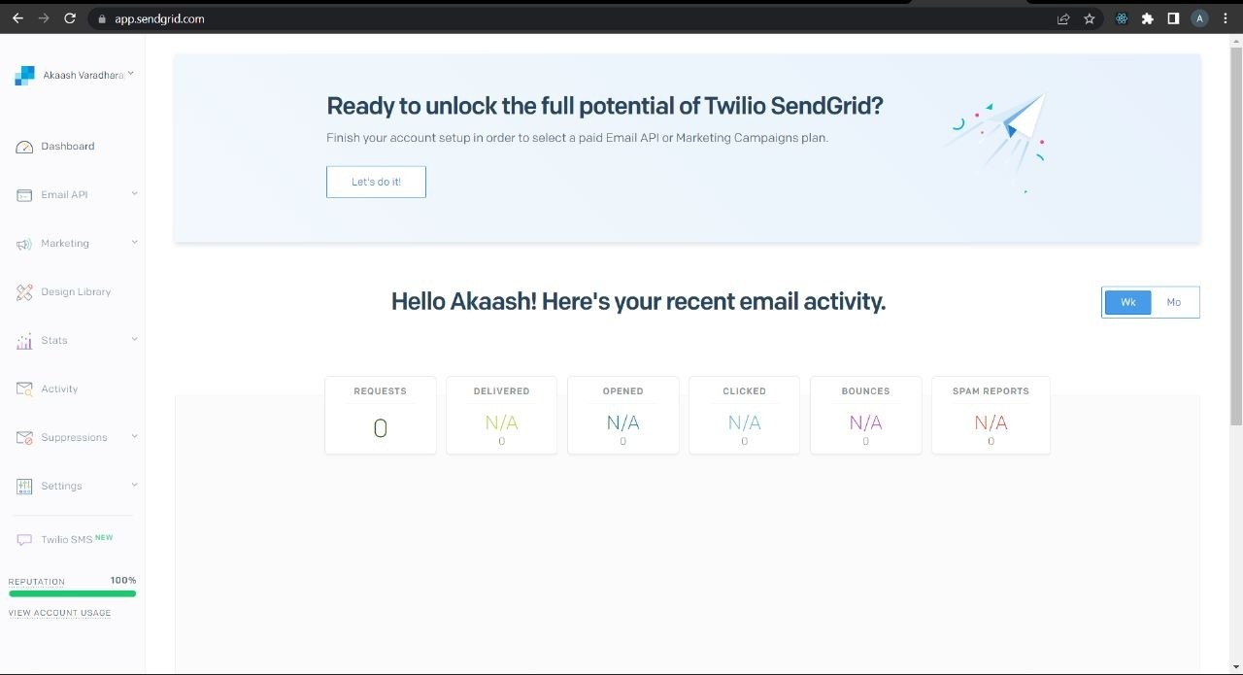Create an Account in Sendgrid: